Regulations 2014
Championship and Trophy

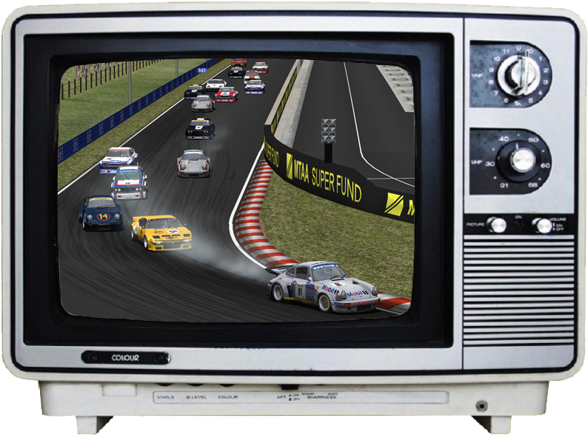

Versions of the document

Version | Changes | Date
1.00 | Initial version | 04/01/2014

1 Introduction 5
1.1 Origins of Old Drivers Spirit 5
1.2 Old Drivers Spirit’s association 5
1.3 What’s new in 2014? 5
1.4 Common rules 6
1.4.1 Gentlemen drivers’ spirit 6
1.4.2 Be ready to… 6
1.4.3 Technical requirement 6
1.4.4 Installing the mod Blender (HGTTC+DRM) 6
1.5 Register 6
1.5.1 Registration on SLS portal 6
1.5.2 Registration on forum 7
1.5.3 A donation to the association ? 7
1.6 On track ! 7
1.7 The race day 7
1.7.1 Absence 7
1.7.2 Deconnection during the qualifications or warm-up 7
1.7.3 Connection problems 8
1.7.4 Chatting 8
1.7.5 Behaviour during all sessions 8
1.7.6 Respect flags 9
1.7.7 Align to the starting grid 9
1.7.8 Overtaking 10
1.7.9 Overtaking lapped cars 10
1.7.10 Collision 10
1.7.11 After a somersault 10
1.7.12 Cuts 10
1.8 After the race 13
1.8.1 Claims 13
1.8.2 Classification 13
1.8.3 Rules of penalities 13
2 Springtime & fall championships 14
2.1 Final classification 14
2.2 Titles 14
2.3 Choice of cars 15
2.4 Private garage 15
2.5 The time schedule 15
2.6 Springtime championship’s calendar 16
2.7 Fall championship’s calendar 16
2.8 Groups 17
2.9 Points distribution 18
2.10 Bonus 18
2.10.1 Pole 18
2.10.2 Best lap in race 18
2.10.3 Car selection 18
3 Interleague Trophy 19
3.1 Final classification 19
3.2 Titles 19
3.3 Car choice & nickname in game 19
3.4 Weather conditions 20
3.5 Mandatory pit 20
3.6 Rolling start process 20
3.7 Custom cars 21
3.8 The time schedule 22
3.9 Calendar 22
3.10 Class 23
3.11 Points distribution 23

Introduction

Origins of Old Drivers Spirit
The original idea was given in 2007 by Olivier Zaiit, a Grand Prix Legends driver racing into the F1Legends.ch championship.
Some other drivers, Jura & SdP, who like to race on historical touring cars decided to join Olivier to build up the first Old Drivers Spirit championship.
ODS encounter success mainly because of the technical invest of SdP alias Yoda.
First 2 years 2007 & 2008 was on GT Legends from Simbin, the only game which was able to feed our historical racing needs at that time. Since 2009, they decided to switch to rFactor from Image Space Incorporated and his Historic GT & Touring Cars mod from HistoriX mod team.

Old Drivers Spirit’s association
Our events are always free of charge and they are organized by the Old Drivers Spirit’s association. The association exists since 2011, french law 1901.
Drivers can be members of the association with a donation of 15€ minimum for one year. The donations are used to cover the cost of dedicated servers and the forum. As a member of the association, you can have some special rights but nothing on the sportive side.
More information are available on the « Association Old Drivers Spirit » topic on the forum.

What’s new in 2014?
- Availability of ODS Blender mod which is the reunion of HGTTC 1.95 mod & DRM 2.02b mod.
- We will use Plugin RFE v1.2 (now Win8 compatible) for some championship and trophy race. This plugin allow to race under various weather conditions including rain.
- Trophy: the endurance trophy is renamed Interleague trophy. The night of the race is now on Tuesday. The number of race is reduced to five and those have now a length of 90 minutes.
- Championships : springtime’s them will be cars from sixties on track from the past. Fall’s them will be cars from seventies on actual tracks.
- In case of responsability in a collision, you have now to make a drive-through penality on your next lap instead of waiting your opponent.

Common rules

Gentlemen drivers’ spirit
All the basic rules off an online championship apply. Fairplay, driving pleasure and respect of the others must be the basis of any driver wishing to enter one of our championships.

Be ready to…
- ride with 100% damage, mandatory cockpit view, with the possibility to have automatic (only help available).
- have Gentleman Drivers’ spirit ! Not to force the way on lapped driver, to make a drive-through when you have pushed (even accidentally) an opponent, etc.

Technical requirement
A racing wheel is required to participate unless special permission. It is not mandatory to have a clutch pedal.

Installing the mod Blender (HGTTC+DRM)
A specific installation for the championship & the trophy is necessary (we made ​​corrections and reorganized cars). Synchronization tool is available for the ODS Blender mod and the tracks. The tool has to be used for future update.
Use of this mod is strictly reserved for competitions organized by Old Drivers Spirit. In this way, the tool is protected by a password which is communicated at the driver when he registers. This password could be change during the year; the new one will be communicated. If the password is not sent to you even your registration, don’ hesitate to contact us on the forum…
Details of the installation steps are available via the briefing of the season on the forum, in “Les courses” section.

Register

Registration on SLS portal
To participate, you simply need to register on the SLS module website :
http://www.old-drivers-spirit.info/sls/
Once registered, simply select the type of event that you want to take part (Championship and/or Trophy). For the trophy, select a car for the season.
You will find the steps to a registration in SLS at this address:
http://www.old-drivers-spirit.fr/fichiers/2009/inscription2009.html

Registration on forum
Feel free to register on the forum to participate in the life of the championships, follow driver’s moods or informations about championships.

A donation to association ?
Participation in Old Drivers Spirit events is free, but dedicated servers and forum have a cost. If you are satisfied by organized events and you took lot of fun on track on our servers, feel free to make a donation to help the Old Drivers Spirit association! (see section 1.2, page 5)

On track !
For your training sessions, a server for the Championship and another one for the Trophy are available with the track/cars combination for the next race. You can compete against other drivers or perfect with them.
To facilitate communication, a voice server (TeamSpeak3) is also available.
During training we can only advise you to respect the rules described for the race day (below) to properly integrate them. Non-compliance with these rules causing several accidents with another driver or bad behavior towards another driver may be sanctioned by the Commissioners.

The race day

Absence
If you have an absence/impediment, thank you to let us kindly know in the subject of the relevant race at the "2014 Championship" or "2014 Trophy" section on the forum.

Deconnection during the qualifications or warm-up
A disconnection of one or more drivers during qualifying or the warm-up, their return is expected in 8min max from the time the weekend is restarted on the server. Only one restart will be performed.
Other drivers must remain ready to take the start, the race may be started before the limit 8min when everyone is connected. During this waiting time, if a driver disconnects, it will be expected, but still under the initial 8min retries caused by the first pilot disconnected.
Once all the drivers are finally connected, the administrator decides to go to the race session or wait until the end of warm-up.
Any recovery is excluded for:
- an installation problem or gamedata sync.
- connection lost during the launch of the race session or during 30s waiting time before race.
If a driver voluntarily leaves the event during qualifying or warmup, it is requested to report it in game chat so to not make unnecessary restart.

Connection problems
In case of disconnection by several drivers on a server or on a decision of the administrators, the race will, as far as possible, stopped and the server restarted. If the grid cannot be restored, a qualifying session of 10 minutes will be launched. If one of the races cannot be done, it will be postponed if possible.

Chatting
During qualifying and race sessions :
- Chatting is forbidden
- Only the following abbreviations are allowed
  - « PO » (Pits out) & « PI » (Pits in), as a matter of security at entry and exit pit
  - « SRY » (Sorry) & « NP » (No Problem) in case of collision.
  - « OUT » to mean that the driver who has pulled you no longer needs to wait for you because you cannot restart.
- During qualifications if a driver greet when connecting, wait until the end of qualifications to make a reply.
- At the end of the race and at the end of qualifying, some drivers have not finished their last turn: wait until everyone arrived to chat.

Behaviour during all sessions
- Speed ​​limit in the pits: set at 80 km/h for all tracks, respect it! During the race session you will be penalized by a stop & go.
- Pit exit: some tracks have a white line on track at the end of the pit section, respect it. Drivers on track have also to respect it to not crash on driver entering the track.
- Out of track: Be careful when you come back on track! You had lost time out of track, no need to lose more in crashing into another car…
- Crashed car near the track: if the damaged on your car are too big to continue the race (broken engine for example), press ESC as soon as possible. You can still watch the end of race on the TV monitor in your garage.
- Red light at pit exit: do not enter the track, wait the beginning of the session (the green light).
- The blue light (or yellow) flashing at the end of pit: indicates the imminent arrival of a vehicle on the track, when you exit the pit, make sure to not cause any inconvenience to that vehicle

Respect flags
- Drapeau Jaune
  - Be careful and reduce your speed: it indicates that there is an incident. Be vigilant all the times during the yellow flag and reduce your speed. If visibility is lacking, to increase it, it is strongly recommended that you enable the identities of cars. Identities can be displayed continuously or keypress in game.
  - Overtaking is strictly prohibited
- Drapeau Bleu
It indicates that you are in front of a driver who is about to take you one lap, you must facilitate overtaking:
  - As soon as you can
  - Without taking risk, both for you and him
You can keep your normal path, but without obstructing the way too long! Otherwise, you risk a penalty.
Some parts or the track are good for overtaking by relaxing the gas pedal a little. But don’t brake violently or make a strong change of path suddenly, as those moves can surprise the driver behind you.
On the other side, the driver who is overtaking doesn’t have the right to force his way and to put into troubles another driver with his overtaking move. It’s him who got the responsibility to know when he could pass without risk.

Align to the starting grid
- Once your car is on the grid, it is strictly forbidden to return to the pits and get back into grid.
- Before each race, there are a few minutes of warm-up (4 min. in championship / 8 min. in trophy). During the warm-up, make sure you have loaded your race setup.
- A pilot who returns to the pits (from ESC) and then replace on the grid (control from the replay server) will be disqualified when making the final classification of that race.

Overtaking
Pilots battles must remain correct between them and must respect the limits of the track. Too many changing lines are to be avoided as well as putting the other driver into danger (push him to the outside of the track for example).

Overtaking lapped cars
See blue flags rules (section 1.7.6, page 9).

Collision
After a collision, the guilty driver or drivers of the incident have to make a drive-through in the next lap. This rule should apply regardless of the classification of drivers involved (lapped or not).
If the car of responsible driver or drivers is damaged, they can repair it at the pit before doing the drive-through. In consequence, the drive-through has to be done the lap after the reparation.
Excuses can be given either via chat message (“Sry”) or on the forum after the race.

After a somersault
After a somersault, it is mandatory to pit in the next lap and to make a "COMPLETE" repair of the car (tires and gasoline non-mandatory). If the somersault happens on the last lap, no repair is asked. NB: a somersault is the fact to have the roof of your car at the floor of the track and to have the wheels looking at the skies…

Cuts
La piste est délimitée par les lignes blanches ainsi que par les vibreurs, la voiture doit toujours avoir au moins une roue sur la piste. En l'absence de ligne blanche, le macadam délimite la piste.
The track is marked by white lines as well as kerbs, the car must always have at least one wheel on the track. If no white line, the tarmac defines the track.
Any position gained through a cut must be given back as soon as possible.
Commissioners will conduct a control of the cuts on some races on some track. Will mainly be monitored:
- The repeated cuts
- The big cuts (straight regardless of the corner for example)
- Cuts with a gain of time, even on a loss of control
Given the heterogeneity of cars and to not be a victim of a runway excursion, it was not added anti-cuts items that can cause a collision.
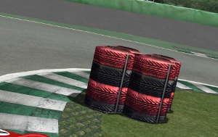
In some corners, tires have been to mark the chicane and to avoid time-gaining cuts.
Those tires aren’t walls, so the damages resulting by hitting them are weak.
- Examples for cuts:
  - Authorized
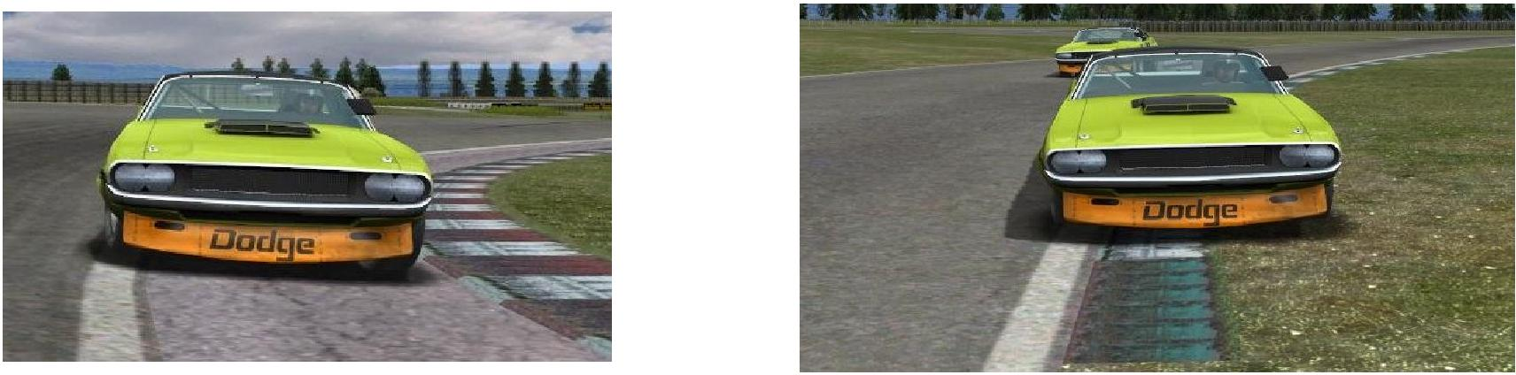

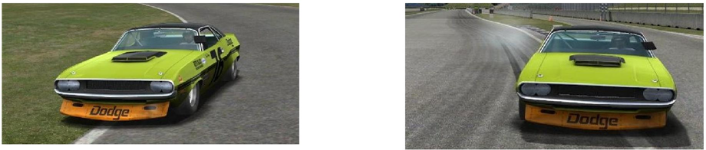

  - Forbidden

4 wheels off-road
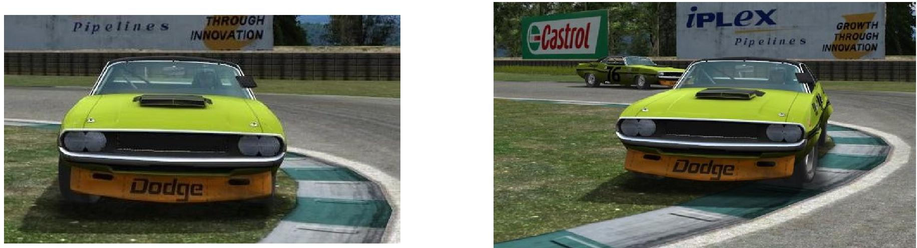

After the race

Claims
Any driver can complain by email during the week of the race concerned. Claims have to be mail at: commissaires2014@old-drivers-spirit.fr

Classification
The ranking is based on the export server and displayed in SLS portal. Classification is generally available the evening of the race, however, it is not final at this time. Penalties may be added later.

Rules of penalities
Summary of penalties after analysis by Commissioners

Reason | Actions | Penalty
Minimum penalty | Various, according to commissioners' decision / behavior of drivers | Warning  - after 3rd warning  Loss of 10 points  + start on last position (no qualy) on the next race with a drive-through at the end of 1st lap.
Cut | Driving off-road in a corner/curb | Repetitive cuts: loss of 3 places in the standing of the race  Abusive cut: 30 sec. of penalty
No fairplay behaviour | - Pushing and no drive-through  -Force the way  - Gain a position by cutting  - Overtaking before the starting line  - Non-respect of blue flag  - Overtaking under yellow flag | 1 lap penalty by action
Incomplete pit (trophy) | Do not change all 4 wheels at least one time over the entire race | 2 laps penalty
No Pit (trophy) | To not going to pit during entire race | 4 laps penalty
Sommersault | Don’t go to pit for complete repairs (exception if it happens on the last lap of the race) | 4 laps penalty
Dangerous behavior on the track | To behave voluntarily dangerously with others | Disqualification
Pit (trophy) | Pitting only on the last lap of the race | Disqualification
Align on starting grid | When on grid, pressing ESC to return to pit and then come back on grid | Disqualification

Springtime & fall championships
In 2014, two championships of 8 races will take place. The first one during the first half of the year. The 2nd during the… second half. The regulations for these two championships are the same, only changing the name of the title and the dates.
RFE 1.2 plugin allowing variable weather will be used sporadically during the year. (for more informations see section 3.4 on page 20)

Final classification
Final classification of each championship is established on 7 best races for each driver (on the 8 races). In case of tie, only the number of victory tiebreaker two pilots. If they have the same number of victory, they will be classified at the same position.

Titles
- Springtime champion
The springtime champion title will be awarded to the driver who has scored the most points at the end of the springtime championship.
- Team springtime champion
The best team of 2 drivers at the end of the championship will be the sringtime champion team. Teams have to be made and announced before the start of the championship. Think of a logo!
- Fall champion
The fall champion title will be awarded to the driver who has scored the most points at the end of the fall championship.
- Team fall champion
The best team of 2 drivers at the end of the championship will be the fall champion team. Teams have to be made and announced before the start of the championship. Think of a logo!

Choice of cars
For each round, a specific group of cars is selected. The driver selects a car in this group for the race day. There is no obligation to announce his choice of car.

Private garage
Every member of the Old Drivers Spirit’s association can have a private garage with their name including 2 personalized skins by group of cars we will use during the season.
Some points to observe:
- The skins must meet a minimum historical appearance and/or aesthetic
- Each skin must be of reasonable size (<10MB for indication)
- Submit a maximum of skins before the start of the season
- During the season, the proposed new skins will be added in the gamedata when we could but no waranty of time
- No removal of skins during the season
Section forum Ressources » rFactor Trucs et Astuces » Skins can help you to do your skin, check and test your skins before you send it to integrate the HGTTC ODS gamedata. Skins once tested have to be send at this address: orga2014@old-drivers-spirit.fr

The time schedule

Session | Timing | Length
Qualifications | 21:00 | 25min
Warm-up | 21:25 | 4min
Race | 21:30 | 1h
End of race | 22:30

Springtime championship’s calendar
Springtime championship takes place in the 1st half of the year.

Round | Track | Country | Date | Group
1 | Longford | AUS | 17/03 | 2
2 | Monaco (1965) | MON | 31/03 | 1
3 | Rouen (1974) | FRA | 14/04 | 3
4 | Liepziger | GER | 28/04 | 1
5 | Cadwell Park | UK | 12/05 | 2
6 | Monza (1965) | ITA | 26/05 | 3
7 | Paramount Ranch | USA | 09/06 | 1
8 | Herm. Rodriguez (1965) | MEX | 23/06 | 3

Fall championship’s calendar
Fall championship takes place in the 2nd half of the year.

Round | Track | Country | Date | Group
1 | Suzuka | JAP | 15/09 | 4a
2 | Sears Point | USA | 29/09 | 4b
3 | Spa | BEL | 06/10 | 5
4 | Brands Hatch | UK | 20/10 | 4a
5 | Imola | ITA | 03/11 | 5
6 | Dijon | FRA | 17/11 | 4b
7 | Ledenon | FRA | 01/12 | 5
8 | Bathurst | AUS | 15/12 | 4a

Groups

- Group 1
Alfa Romeo 1600 GTA Trans-Am [2] | Fiat Abarth Coppa Mille [3]
Alfa Romeo 1600 GTA [1] | Ford Cortina Trans-Am [3]
Alpine Renault A110 1600s [1] | Lotus Elan 26R [0]
Austin Mini Cooper S 1310 [5]  BMW 2002ti [3]  Ferrari Dino 246GTS StreetCar [4] | Lotus Cortina [1]  Porsche 911S 2.0 [1]

- Group 2
Aston Martin DB4 zagato [2] | Ford Mustang 1965 [0]
Austin Healey 3000 MkIII [2]  Ferrari 275 GTB [1] | Ford Mustang Trans-Am 1966 [1]  Jaguar E-Type Coupe [2]
Ford Falcon Sprint [1] | Mercedes Benz 300SL [5]

- Group 3
Alpine Renault A110 1800WB [4]  Chevrolet Camaro Z/28 1967 [0] | Mercedes Benz 300SLR Uhlenhaut [5]  Porsche 911R 2.0 DOHC [2]
Chevrolet Corvette Stingray 1965 [4] | Shelby Cobra 289 [3]
Ferrari 250 GTO [3] | Shelby GT 350 [4]
Jaguar E-Type Lightweight [2]

- Group 4b
Alfa Romeo 2000 GTAm [4] | Opel GT [2]
BMW 2002tii [4] | Porsche 906 [0]
BMW 2800CS Le Mans 72 [5] | Porsche 911ST 2.4 [1]
Ferrari Dino 246GTS Le Mans 72 [2]  Ford Capri 2600RS Le Mans 72 [3] | Porsche 911ST 2.5 Le Mans 72 [1]  Porsche 914/6 GT 2.5 [0]

- Group 4a
BMW 3.2 CSL Alpina [2] | Ford Capri 2600RS [1]
Chevrolet Corvette Stingray 1974 [1] | Ford Escort MKI 1800RS [0]
Chevrolet Corvette Stingray LM72 [2] | Renault Alpine V6 [0]
De Tomaso Pantera Private [3]  Ferrari Daytona GTB/4 Le Mans 72 [0] | Porsche 906 FIA [0]  Porsche 911 RS 2.8L [0]

- Group 5
BMW 3.5 CSL Schnitzer [2] | Ferrari Daytona GTB/4 Le Mans 72 [5]
Chevrolet Corvette Stingray 1969 [2]  DeTomaso Pantera Factory [2]  DeTomaso Pantera GTS Le Mans 72 [4] | Ford Capri 3100RS [2]  Ford Escort MKI 2000RS [5]  Porsche 911 RSR 3.0 [0]

Points distribution
Ranking is based on the total duration of the race. Any driver who finishes a race score points according to the following table:

1st | 2nd | 3rd | 4th | 5th | 6th | 7th | 8th | 9th | 10th
60 | 58 | 56 | 54 | 52 | 50 | 48 | 46 | 44 | 42
And so on till the last classified driver.
A driver who does not pass the finishing line scores points if he has done at least 50% of the race (but he won’t score bonus related to choice of car).

Bonus

Pole
A bonus of 1 pt is awarded to the fastest driver in qualifying (even if the driver won’t finish the race).

Best lap in race
A bonus of 1 pt is awarded to the best lap in race (even if the driver won’t finish the race).

Car selection
To balance the highly variable performance of cars and amplify the diversity at the races, bonuses are awarded to least efficient cars in their class, allowing them to compete with the best ones in the classification. This bonus is lost if the driver does not cross the finishing line. The bonus is the number in brackets in the table groups you can find on the previous page.

Interleague Trophy

Final classification
Final classification of the interleague trophy is based on all the 5 rounds occurring in the first half of 2014.

Titles
- Endurance trophy of best driver in DRM-A class
The endurance trophy of best driver in DRM-A class is awarded to the driver who has scored the most points with one car at the end of the trophy.
- Endurance trophy of best driver in DRM-B class
The endurance trophy of best driver in DRM-B class is awarded to the driver who has scored the most points with one car at the end of the trophy.
- Endurance trophy of best driver in HGTTC “group 5” class
The endurance trophy of best driver in HGTTC “group 5” class is awarded to the driver who has scored the most points with one car at the end of the trophy.
- Interleague trophy of best team league
Teams representing a league consist of 3 drivers. The drivers of the same team should be divided like this: 2 drivers in DRM-A class and the last one in HGTTC “group 5” class (so no DRM-B class). The interleague trophy for the best team will be awarded to the team that scored the most points at the end of interleague trophy. The teams must be announced before Jan. 27, 2014.

Car choice & nickname in game
- Before the first round, each pilot racing for their own must have selected a class and a car on which he will drive all rounds of the trophy. The choice of car has to be made in SLS portal (see section 1.5.1.)
- For drivers racing for a team, besides having to enroll in SLS, they must also register their team & indicate their 3 cars choice in the specific subject of the forum before January 27: www.old-drivers-spirit.fr/index.php/topic,4737.0.html
- In order to have a nice diversity of cars on the grid, it’s decided that a team is required to choose 3 different manufacturers. (Porsche 935/BMW M1/BMW CSL is not a valid choice for example)
- A team must keep the 3 selected cars during all races, but the team can replace his driver as they want. However, a driver already aligned for one league cannot subsequently be aligned by another league.
- Drivers racing for a team are required to place the tag team before their name/nickname. Tags will be defined by the organization in the forum into the subject speaking about interleague teams (eg "[ODS1]pseudo"). On the contrary, drivers only racing for their own don’t have to use tag before their name/nickname.

Weather conditions
The use of RFE v1.2 plugin allows changes in temperature and rain during some races. Cars can be fitted with rain tires in the garage. A communication on the weather will be announced on the racing day. Warm-up conditions will be very close to the conditions at the start of the race.
Some trophy races will be in "accelerated time." That means 90 minutes of actual races represent a higher number in the game. This obviously implies that part of certain events will take place at night. Virtual start of the race (in the game) may vary from one round to another. It will be announced on the topic of the race.

Mandatory pit
One pit with the change of 4 tires is mandatory. This pit should not be done on the last lap under penalty of disqualification.
Mandatory stop after a somersault (see 1.7.11) does not count as mandatory pit and vice-versa.

Rolling start process
Drivers have to respect this following process (as the server is standing start setup) :
- Drivers joins the grid like for a standing start
When the lights hit green, the formation lap begins. The poleman starts, followed by the others in one row by respecting the qualifications order.
- During this lap, the poleman choose the rhythm with maximum speed at 120 km/h and we ask him to not take any risks (no sudden brake/acceleration).

- Other drivers
  - have also to respect the maximum of 120 km/h
  - cannot overtake the driver ahead of him (except if the driver ahead crash)
- Before the last corner, the poleman reduce the pace at 80 km/h.
- At the end of last corner, drivers can drive as they want but overtaking is still forbidden till the starting line!
Notes :
- During the formation lap, if a driver encounter difficulties he have to wait and must start last. This rule is for one driver who have made a mistake during the formation lap and also for someone who is the victim of another driver.
- There are penalties for not respecting the rolling start process.
- If a driver have to respect a stop&go penalty, he have to start the race like the others, and have to stop at the pit for his stop&go at the end of the first lap of the race (not at the end of the formation lap)

Custom cars
Every driver can skin his own car if he respects those rules:
- Only one skin by driver/car.
- The skin must be send before 27/01/2014 to be integrated to the gamedata.
- Respect a minimum the period style and/or esthetic, too wacky customizations will not be added.
- No skin update allowed, except for problem related to these.
- The organizers reserve a period of time to add a custom car during the season (for drivers joining us during the season)
Skins have to be send to this address: orga2014@old-drivers-spirit.fr

The time schedule

Session | Timing | Length
Qualifications | 20:45 | 25min
Warm-up | 21:10 | 8min
Race | 21:20 | 1h30
End of race | 22:50

Calendar
The interleague trophy is taking place on the first half of the year.

Round | Track | Country | Date
1 | Nordschleife | GER | 11/02
2 | Daytona | USA | 04/03
3 | Interlagos | BRA | 08/04
4 | Le Mans (1991) | FRA | 06/05
5 | Solitude (1964) | GER | 03/06

Class
- DRM-A Class
BMW M1 Turbo | Porsche 935
Ford Capri Turbo | Toyota Celica Turbo
- DRM-B Class
BMW 320 Turbo | Lancia Beta Montecarlo
- HGTTC « Group 5 » Class
BMW 3.5 CSL Schnitzer | Ferrari Daytona GTB/4 Le Mans 72
Chevrolet Corvette Stingray 1969  DeTomaso Pantera Factory  DeTomaso Pantera GTS Le Mans 72 | Ford Capri 3100RS  Ford Escort MKI 2000RS  Porsche 911 RSR 3.0

NB: Italic cars are available but discouraged because they are theoretically disadvantaged compared to other cars in the same class.

Points distribution
Ranking is based on the class and on the total duration of the race. Any driver who finishes a race score points according to the following table:

1st | 2nd | 3rd | 4th | 5th | 6th | 7th | 8th | 9th | 10th | 11th | 12th
15 | 12 | 10 | 9 | 8 | 7 | 6 | 5 | 4 | 3 | 2 | 1
A driver who does not pass the finishing line scores points if he has done at least 80% of the race (relative to the class leader).
If a driver has not driven on the same car as on his 1st round (forbidden for individual classification but authorized for team classification), he will score points for his team but no point for individual classification.

